SIMPLE HOUSEHOLD APPLIANCE WARRANTY TRACKER
@CREATIVITY THINK (9483175986/7019689991)

ABSTRACT:
The Simple Household Appliance Warranty Tracker is a web-based platform designed to help families, PGs, and small businesses manage appliance warranties efficiently. The system allows users to add appliance details, upload bills or warranty documents, track warranty expiry dates, and receive automated reminder alerts for service or renewal. Administrators can manage default warranty templates by brand and type, publish maintenance tips, and monitor dashboard insights on appliance categories and expiry patterns. Developed with Django and Django REST Framework for backend processing, and React with axios and react-table for frontend functionality, the platform provides structured, timely, and user-friendly warranty management..

INTRODUCTION OF THE PROJECT:
Households and small organizations often face difficulties tracking multiple appliance warranties, service dates, and documents, leading to expired warranties or missed service calls. Traditional manual tracking methods, such as notebooks or spreadsheets, are inefficient and error-prone. The Simple Household Appliance Warranty Tracker addresses these challenges by providing a centralized digital solution. Users can track warranty durations, receive timely reminders, and maintain all appliance-related documents in a structured way. Administrators gain insights into popular appliance categories, warranty expiry trends, and can share maintenance tips to improve appliance lifespan..

PROJECT OBJECTIVES:

• Enable users to add appliances with detailed profiles including brand, model, purchase date, and bill photo
• Automatically calculate warranty expiry dates and alert users proactively
• Track appliance service visits and warranty status (active/expired)
• Provide dashboards to view active and expired warranties
• Allow administrators to manage default warranty templates for brands and types
• Publish maintenance tips and guidelines via admin dashboard
• Export reports for business insights on service patterns and appliance trends
• Improve household and small business appliance management efficiency
• Provide a secure, scalable, and user-friendly platform

PROBLEM OF THE STATEMENT:
Tracking multiple appliance warranties manually is inefficient and error-prone. Users often forget warranty expiry dates, misplace bills, or miss important service deadlines, leading to financial losses or reduced appliance lifespan. Small service businesses lack analytics to identify trends in warranty expirations. The Simple Household Appliance Warranty Tracker solves these problems by automating warranty calculations, sending reminders, centralizing documents, and providing administrative dashboards for monitoring trends..

MOTIVATION OF THE PROJECT:
• To digitalize household and small business appliance warranty management
• To prevent expired warranties and missed service reminders
• To centralize appliance-related documents and bills
• To simplify tracking of multiple appliances and warranty types
• To provide actionable insights for service businesses via admin dashboards
• To offer a convenient and intuitive interface for users and administrators
• To enhance organization, planning, and appliance maintenance

BLOCK DAIGRAM OF PROJECT:

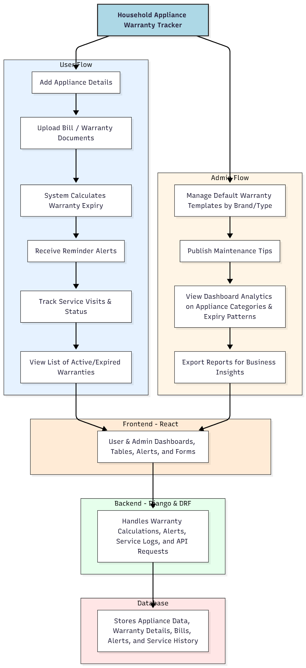

WORKING OF THE PROJECT:
Users add appliance details including brand, model, purchase date, and bills or warranty documents. The backend system calculates warranty expiry dates automatically and sends timely reminder alerts. Users can track service visits, view active and expired warranties, and maintain all appliance documents centrally. Administrators manage default warranty templates by brand and type, publish maintenance tips, monitor analytics on appliance expiry patterns, and export reports for insights. React and react-table handle frontend dashboards, forms, and tables, while Django and DRF manage backend processing, API requests, and database interactions. This system ensures accurate tracking, organized document management, and improved appliance maintenance..

SOFTWARE REQUIREMENT:
- Backend:
  - Python 3.x
  - Django
  - Django REST Framework
  - SQLite/PostgreSQL
- Frontend:
  - Node.js and npm
  - React.js
  - Axios
- Development Tools:
  - Visual Studio Code
  - Postman (for testing APIs)
  - Git/GitHub (for version control)
- Server/Deployment (Optional):
  - Gunicorn, Nginx, or Heroku/AWS for hosting

ADVANTAGES OF THE PROJECT:

• Centralized tracking of household and business appliance warranties
• Automatic calculation of expiry dates and timely alerts
• Stores all bills and warranty documents securely
• Dashboard analytics for administrators
• Facilitates proactive maintenance and service
• Reduces risk of expired warranties and missed service visits
• Generates reports for service business insights
• Enhances organization and user convenience

APPLICATIONS OF THE PROJECT:
• Families and shared accommodations (PGs)
• Small businesses and offices
• Appliance maintenance service providers
• Home appliance tracking and planning
• Warranty management for product-based service businesses

REFERENCES:

- Django REST Framework Documentation — Django Software Foundation. Django Documentation. Available: https://docs.djangoproject.com/
- Django REST Framework. DRF Documentation. Available: https://www.django-rest-framework.org/
- React. React Official Documentation. Available: https://reactjs.org/docs/getting-started.html
- Redux. Redux Documentation. Available: https://redux.js.org/introduction/getting-started
- PostgreSQL Global Development Group. PostgreSQL Documentation. Available: https://www.postgresql.org/docs/
- MySQL. MySQL Reference Manual. Available: https://dev.mysql.com/doc/
- Git. Git Documentation. Available: https://git-scm.com/doc
- Node.js. Node.js Documentation. Available: https://nodejs.org/en/docs/
- Axios. Axios Documentation. Available: https://axios-http.com/docs/intro
- Socket.io Documentation – https://socket.io/docs/

